HOLIDAY ACTIVITIES and FOOD (HAF) PROGRAMME GUIDANCE
Spring/Easter Holiday 2021

Department for Education (DfE) PROGRAMME FOCUS

- Relieve pressure points for some families during school holidays as a result of increased costs and reduced incomes.
- Support children who may be more likely to experience ‘unhealthy holidays’ in terms of nutrition and physical health.
- Increase opportunities for children from lower-income families who may be less likely to access fun activities.
- Provide consistent and easily accessible activities, for more than just breakfast or lunch through free holiday clubs.

Who is the Programme aimed at?
The funding is for school age children aged 5-16 years old.
The primary beneficiaries of the programme are intended to be Free School Meal eligible children, but the programme can include support for children and young people facing hardship and to target geographical hotspots showing high levels of economic disadvantage, obesity and deprivation.
Providers may also use their discretion if a parent turns up with younger children.
All provision under this programme must be accessible to any child meeting the criteria and be publicised widely, not just open to the children and young people you work with on a regular basis.

Delivery Format
Over Easter we are looking for providers to offer 16 hours delivery, spread over 4 days (minimum) which include mealtime/lunch/eating space – but we welcome applications willing to provide more.
*All delivery must in-line with NYA Guidance/Covid Related Restrictions in place at time of delivery.

Costing Guide
Face to Face - 16 hours Face to Face groups (10) max (Maximum £110 per person for core support plus food costs)
Online Service - 12 hours engagement and 4 hours food/eating time (Maximum £110 per person for core support plus food costs)
Supporting CYP with SEND needs specifically, we will consider raising your costs to (Maximum £140 per person for core support plus food costs)

*Costings are approximate and include food provision and where needed your costs for delivery – there will be options for free food partnerships that can provide hot food for groups operating face to face or pre ordered pack lunches that can be picked up at a central location in Harrow by the delivery partner and delivered to the Young People engaging in your programme.

Minimum standards for Quality Provision for the programme include:
- Healthy Food
- Enriching activities.
- Physical activity.
- Nutritional Education.
- Relevant Policies and Procedures in place.

Additional considerations:
- Inclusive and accessible provision (e.g. SEND)

Programme Outcomes
As a result of the holiday provision, we want to see children and young people:
- Eat more healthily.
- Be more active.
- Take part in engaging and enriching activities.
- Be safe and not isolated.
- Have greater knowledge of health and nutrition.

PROVIDER STANDARDS must meet DfE Framework Standards as follow:
Food: at least one meal a day (breakfast, lunch, or an evening meal) and all food provided (including any snacks) must meet school food standards (click here for details) DfE expectation is that the majority of food served by providers will be hot, however, they acknowledge that there will be occasions when this is not possible and that a cold alternative should be used or a mixture of the two. All food provided as part of the programme must comply with regulations on food preparation and consider allergies and dietary requirements and preferences as well as any religious or cultural requirements for food.

Nutritional education: there should be an element of nutritional education each day aimed at improving the knowledge and awareness of healthy eating for children. These do not need to be formal learning activities and could for example include activities such as getting children involved in food preparation and cooking, growing fruit and vegetables, and taste tests. You are required to provide one of these sessions in each 16 hours of delivery. We will provide a pack that you can use to support this standard which has been designed and developed by Watford FC Community Sports and Education Trust. This can be adapted to meet your needs if you do not already have your own plan/experience in this area.
Signposting and referrals: this is a key part of the programme and YHF will ensure you know how to engage and signpost families to other services and support that would benefit the children who attend the programme and their families.
This will include sessions or information provided by:
- Citizen’s Advice
- School Nurses, dentists, or other healthcare practitioners
- Family Support Services or Children’s Services
- House Support Officers
- Organisations providing financial education.

*HelpHarrow.org can support you with this and YHF can give you guidance on using the system.
Enriching activities: fun and enriching activities that provide children with opportunities to develop new skills or knowledge, to consolidate existing skills and knowledge, or to try out new experiences. This could include physical activities such as football, table tennis, cricket etc.; creative activities such as putting on a play, junk modelling, drumming workshops; or experiences such as a nature walk, visiting a city farm etc.
Dependent on restrictions in place at the time you will need to think creatively around alternative online activities/delivery plans.
Physical Activities: activities which meet the Physical Activity Guidelines (click here for details) on a daily basis.
Policies and procedures: demonstrating and explaining that they have the relevant and appropriate policies and procedures in place in relation to:
- Safeguarding
- Health and Safety
- Insurance
- Accessibility and inclusiveness (Equalities and Diversity)

*Where appropriate, clubs must also be compliant with the Ofsted requirements for working with children.

Priority for Harrow
We will be looking at applications in terms of meeting the highest of our 4 priorities as set out below:
Applications that:
- Provide for the highest predicted percentage of children and young people in receipt of free school meals.
- Deliver in one or more of the darkest shaded areas indicated as being high in need on the map.
- Propose innovative, creative and enriching programmes for children and young people.
- Focus programme delivery directly on or targeted at social housing estates anywhere in Harrow.

This map shows Free Schools Meal density areas:
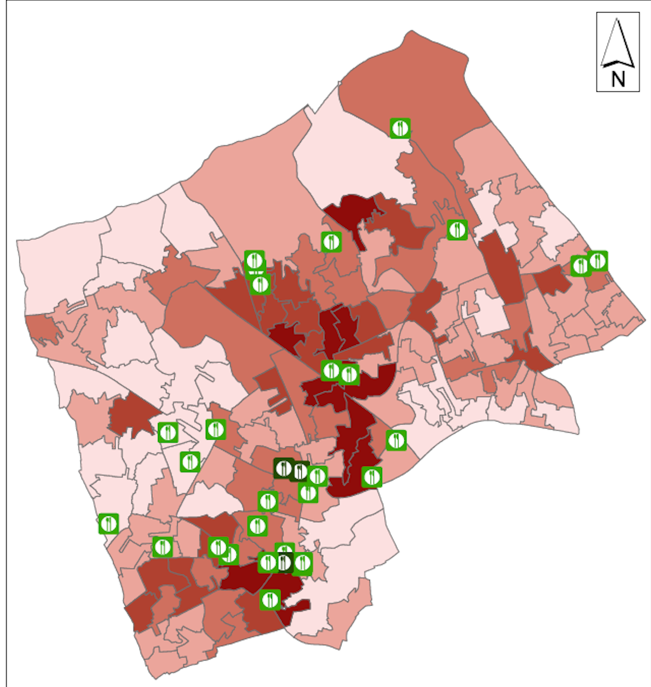

Eligibility Requirements:

- Your organisation must either be based or deliver services for children and young people in Harrow.
- All face-to-face activity should take place in Harrow for school aged children 5-16 years of age.
- All of the proposed activity must be delivered during the Spring/Easter Holiday period for 2021.
- Your organisation must have a bank account registered in the name of the organisation.
- Your organisation must have the following policies in place: Safeguarding, Health and Safety, Insurance and Accessibility and inclusiveness/Equalities and Diversity)
- Your organisation must have a Risk Assessment in place for all activities.
- Your organisation – cooking you own food must have fully qualified staff to deliver this.
- Grants cannot be for religious or political activity which is not for wider public benefit.
- You must agree to publicise your HAF programme on the YHF website (support offered).
- Use at least one social media platform (support can be offered with set up) and to promote your
activities and success of your programs.
- Inadequate delivery/not meeting the standards required and/or late monitoring will affect your
eligibility to apply in future rounds.

- Applications will only be considered if received by the deadline.

DEADLINE DATE: 5.00pm on WEDNESDAY 10 MARCH 2021
ALL SUBMISSIONS should be emailed directly to: HAF@youngharrow.org

You will be notified of the decision no later than two weeks after submission with payment being made the following week upon receipt of your signed GRANT Agreement.

