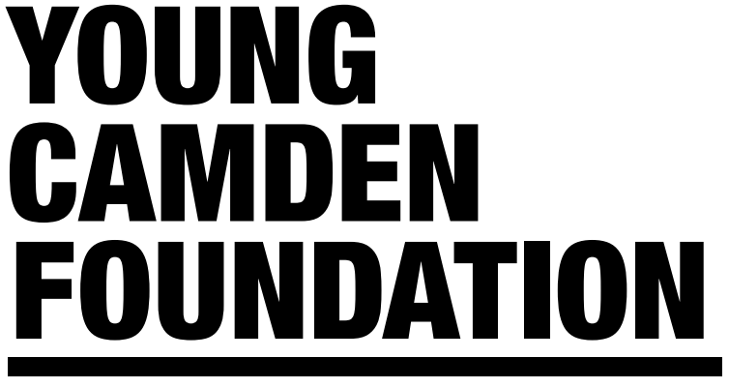
Job Title: Operations Manager
Location: Young Camden Foundation Office
Salary: £30,000 – 35,000 Pro rata
Reporting to: CEO
Hours: 22.5 hours per week

About Young Camden Foundation
Young Camden Foundation provides a positive new approach to supporting the Children and Young People sector. We are determined to safeguard high-quality play and youth provision in the borough.
Our mission: To encourage and assist our members, partners, and supporters in connecting and working together to form innovative and sustainable opportunities for young people. We aim to do this by utilising our networks to broker more investment and build more capacity in the Children and Young People sector.
Our values: Collaboration; equality; community; sustainability.
Our objectives:
- Increase long-term investment in the Children and Young People sector in Camden
- Enable new cross-sector collaboration between members, partners, and supporters
- Ensure that young people feel safe, listened to, and are thriving and achieving their full potential
- Ensure that members have the capacity to deliver high-quality and sustainable youth provision
About the role
This is an exciting opportunity for a passionate, dynamic, and proactive individual to join the Young Camden Foundation as the Operations Manager. YCF is a membership organisation and crucial to the success of the role will be the ability to help build and manage the network by fostering good relationships and creating strong partnerships that are able to collaborate.
Main Duties and Responsibilities:
- Act as a senior member of the YCF Team, contributing to the development of the organisation’s strategy for achieving its charitable objects, and helping to foster the organisation’s values

- Develop and lead a dynamic and exciting new consortium, set up in response to local and national policy initiatives which open up new opportunities for the youth sector in Camden

- Support the development of a business plan with priority areas for the sector identified in conjunction with key stakeholders

- Identify opportunities to improve YCF’s financial position through increased income generation or operating efficiencies, while maintaining the organisations high standards
- Support the CEO funder relationships and develop innovative approaches to attracting core funding through compelling new development proposals and bespoke fundraising events

- Support the CEO with developing and embedding the organisation’s commercial and business engagement strategy

- Ensure YCF is as needs led as possible by maintaining a contemporary understanding of issues facing our members and children and young people

- Support the YCF Membership Officer to implement a communication and engagement plan to raise the profile of YCF amongst providers, potential funders and key stakeholders

- Supervise Business Administration Apprentice and other YCF volunteers, and interns

- Make regular updates to the website, database and social media channels

- Write and distribute the bi-monthly electronic newsletter

