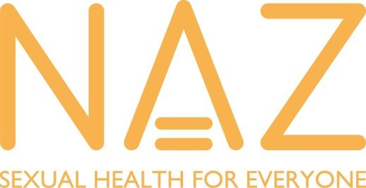
Sexual Health Outreach Volunteer
Role Description

Volunteer Title Sexual Health Outreach Volunteer
Expenses: Lunch and travel expenses covered
Based: Hammersmith with travel to other London boroughs
Reports to: Sexual Health Coordinator

The Organisation:
NAZ is the sexual health charity dedicated to delivering culturally-specific sexual health services to those historically left behind. We are one of the longest-established charities to focus predominantly on sexual health improvement and HIV support services for BAME communities.

We do this because there’s a big gap in the sexual health outcomes of Black Asian Minority Ethnic (BAME) communities compared to the general population.
Through our outreach, programmes, services, and events, we reach around 10,000 people each year.
We work across four key areas:
- HIV care and support services, including advocacy and counselling, for people living with affected by HIV
- Sexual health promotion, including targeted support for BAME LGBTQ communities, faith communities and those at risk of acquiring HIV, STIs and experiencing poor sexual health
- Clinical services, such as HIV testing and screening
- Research, evaluation and policy development

Required commitment: NAZ expect a minimum monthly commitment of 7 hours for a minimum of six (6) months once trained. Once a session is scheduled and agreed to, attendance is mandatory. Unexcused absences without prior notice of 3 times will be grounds for dismissal as a volunteer.

Volunteer Specification
The selection panel will assess candidates against these criteria; please address each point in the person spec in your application form.
Requirements | Essential | Desirable
EDUCATION/QUALIFIACTION/EXPERIENCE  No formal qualifications are required  Good knowledge of English  Knowledge of one or more other languages of the BAME community (Spanish, Portuguese, French, Hindi, Punjabi, Gujarati, Pidgin-English, Mandarin, Arabic etc.) | Essential | Desirable
KNOWLEDGE  No formal knowledge of HIV is required a broad knowledge on sexual health and the BAME community is  Desirable  Experience of working as part of a team or group  Knowledge of current issues relating to HIV and the BAME community in London |  | Desirable  Desirable  Desirable
SKILLS AND ABILITIES  Good communication skills including being able to talk to people face to face by themselves or in a group  Ability to keep clear records of information/reports  Be good at listening to people and able to get on with different kinds of people  Understand , respect and maintain confidentiality  Understand and work within appropriate boundaries  Be respectful and value people regardless of background  Be able to learn from your own experiences  Be able to identify risks and follow procedures | Essential  Essential  Essential  Essential  Essential  Essential  Essential  Essential

Please note that this post will be subject to an enhanced DBS and barred lists check

